**Saral Telemetry - Firebase google analytics** **1**

● Overhead of Firebase Analytic 2

● App Size with new libs 2

● Events we are capturing 2

1. User activity over time 3

2. Views by Page title and screen class 3

3. Event count by Event name 4

4. App stability overview 4

5. Average engagement time 5

6. Latest app release overview 5

7. Device model /country /user 6

**Saral Telemetry - Firebase google Crashlytics** **7**

● Overhead of Firebase Crashlytics 7

● App Size with new libs 7

● Events we are capturing 7

1. Crash-free users 7

2. Issues 8

3. Crashlytics dashboard 8

4. Events 9

Stack trace 9

Logs 9

User Device Data 10

# 

# 

# Saral Telemetry - Firebase google analytics

#### 

#### **Overhead of Firebase Analytic**

Adding Google Firebase Analytic didn't make any effect to the app performance, processing time didn't slow down,its working as before

#### **App Size with new libs**

I have added some libraries for google analytics which is affect the app size in (700kb) **"@react-native-firebase/analytics","@react-native-firebase/app",**

#### 

#### **Events we are capturing**

##### User activity over time

##### **Views by Page title and screen class**

##### **Event count by Event name**

##### **App stability overview**

##### **Average engagement time**

##### **Latest app release overview**

##### **Device model /country /user**

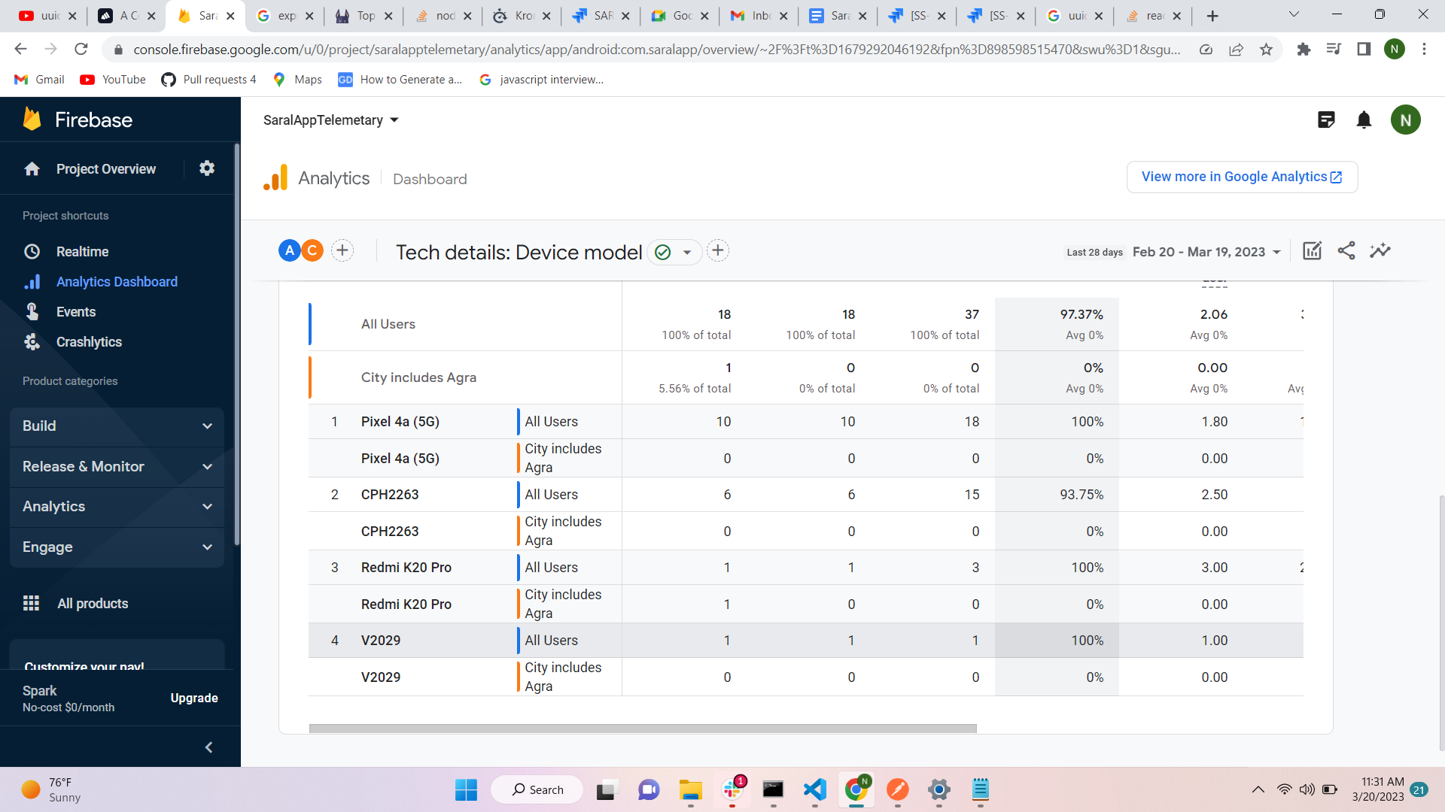

# Saral Telemetry - Firebase google Crashlytics

### Overhead of Firebase Crashlytics

Adding Google Firebase Crashlyticsdidn't make any effect to the app performance, processing time didn't slow down,its working as before

### App Size with new libs

I have added some libraries for google analytics which is affect the app size in (700kb) **"@react-native-firebase/crashlytics","@react-native-firebase/app",**

#### **How it works in offline mode**

for offline support we need to enable real time database

### Events we are capturing

##### **Crash-free users**

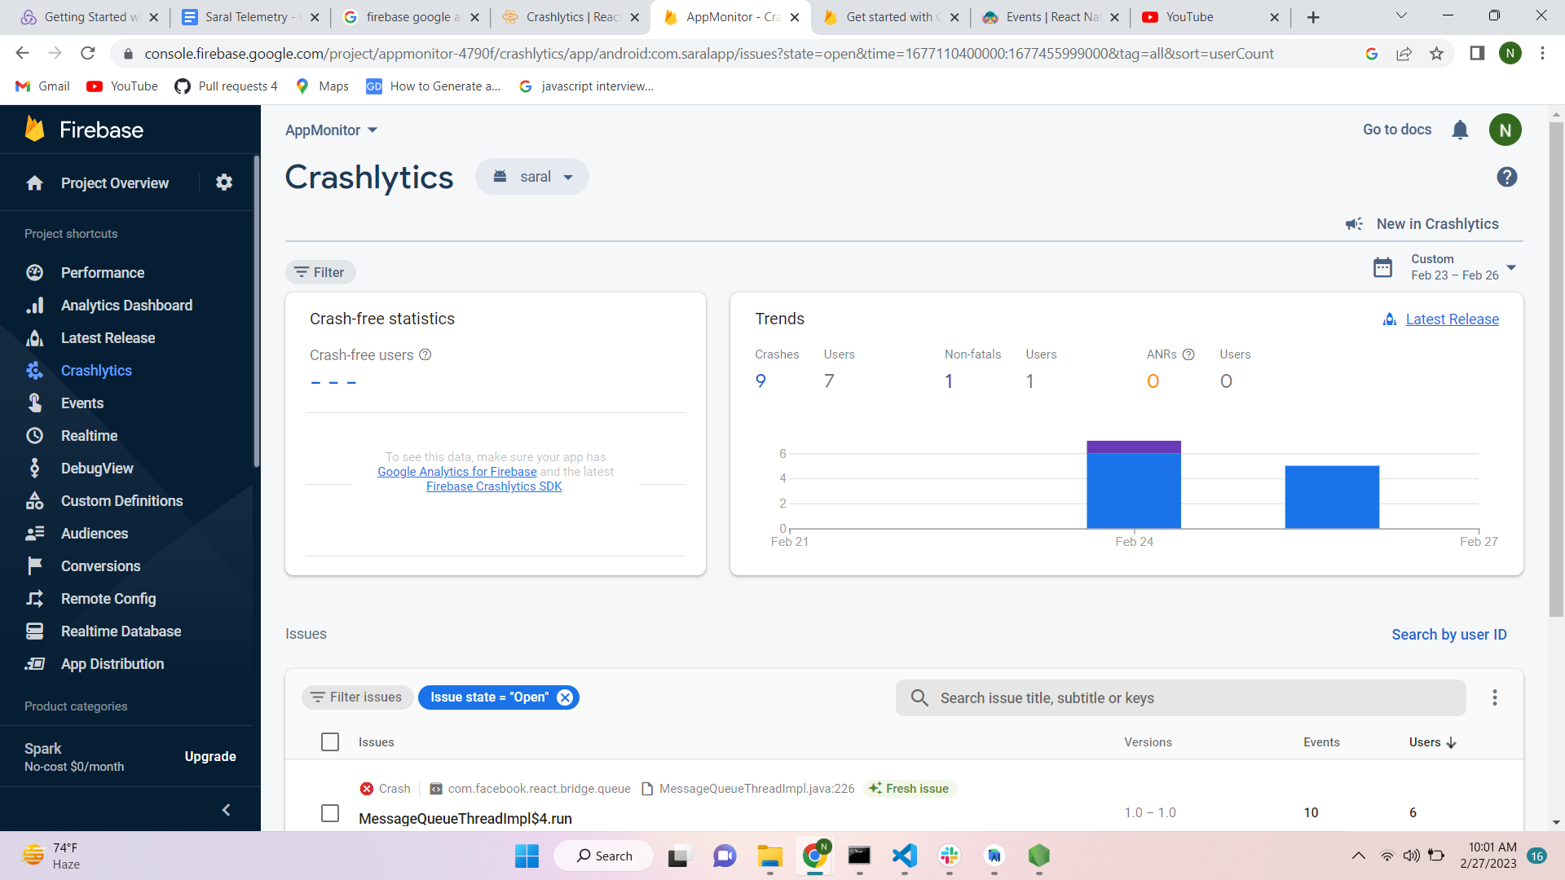

##### Issues

##### Crashlytics dashboard

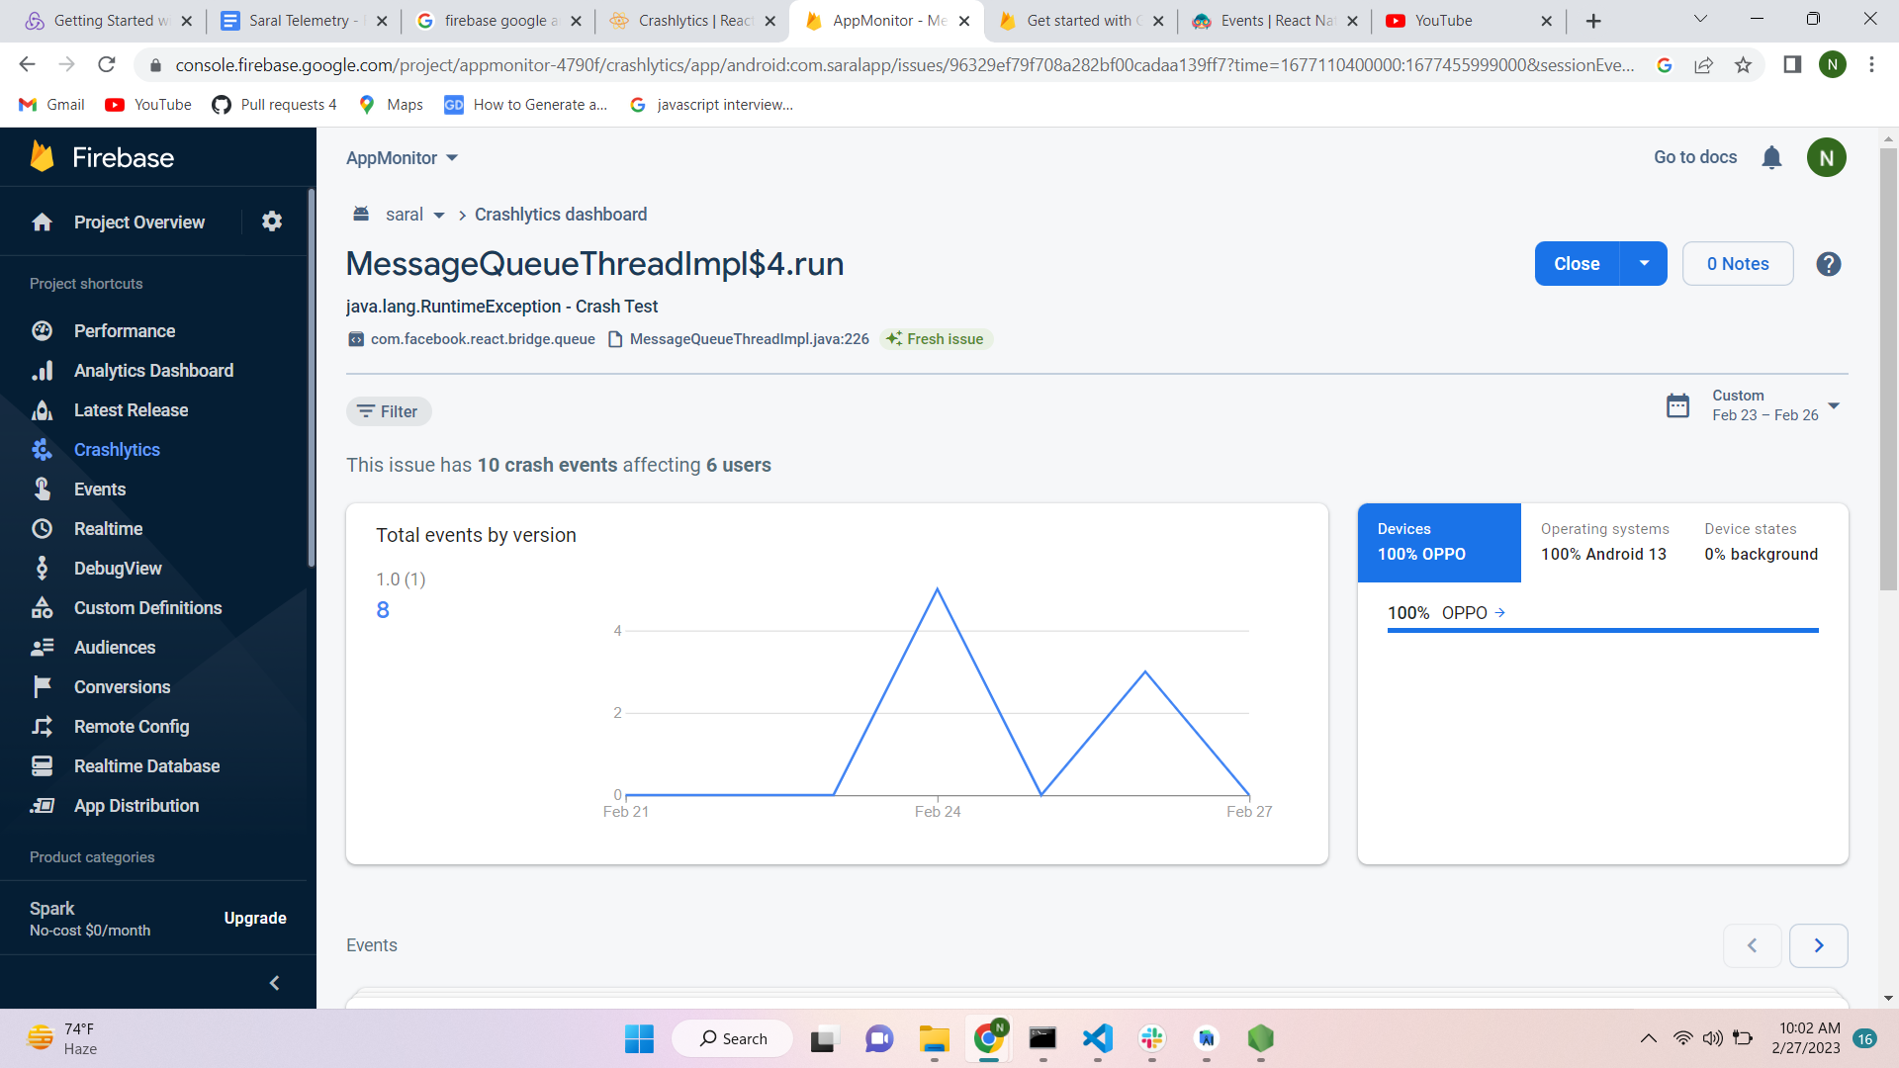

##### Events

###### Stack trace

###### Logs

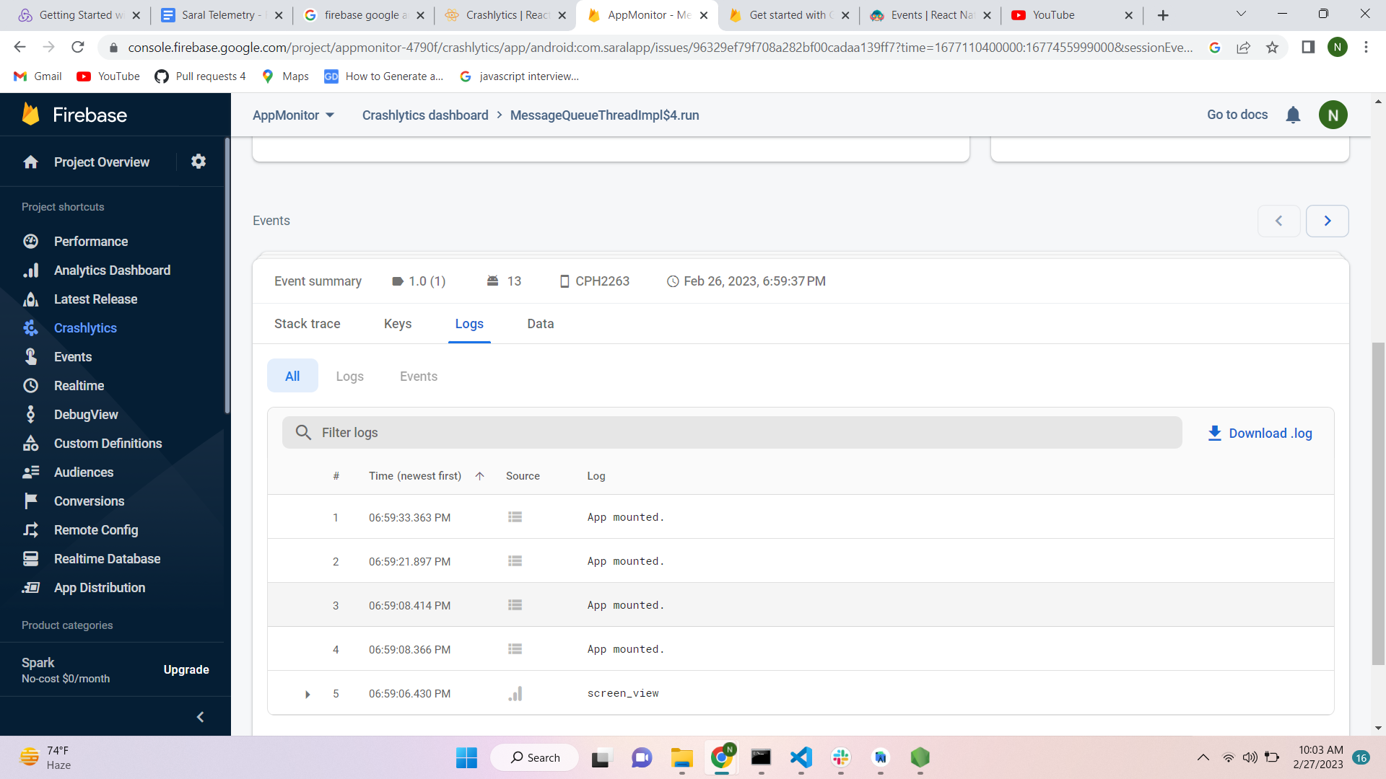

###### User Device Data